# **How to Create a Batch File to Run Python Script**

In this tutorial, I’ll show you the steps to create a batch file to run a Python script using a simple example.

But before we dive into the example, here is the batch file template that you can use to run the Python script:

"Path where your Python exe is stored\python.exe" "Path where your Python script is stored\script name.py"

pause

In the next section, I’ll review an example to create a batch file that will launch the [Python GUI](https://datatofish.com/how-to-create-a-gui-in-python/) below. The same concepts would apply for any Python script that you’d like to run using a batch file.

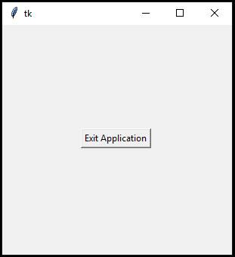

## **Steps to Create a Batch File to Run Python Script**

### **Step 1: Create the Python Script**

To start, create your Python Script.

For example, I used the below code to create a [simple GUI](https://datatofish.com/how-to-create-a-gui-in-python/) with a single button to exit the application.

Alternatively, you may use any Python code that you’d like.

import tkinter as tk

root= tk.Tk()

canvas1 = tk.Canvas(root, width = 300, height = 300)

canvas1.pack()

button1 = tk.Button (root, text='Exit Application', command=root.destroy)

canvas1.create_window(150, 150, window=button1)

root.mainloop()

### **Step 2: Save your Script**

Save your python script (your python script should have the extension of ‘.py’).

In my case, I saved the Python script as **simple_gui**

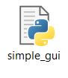

### **Step 3: Create the Batch File**

To create your batch file, open Notepad and then use the following template:

"Path where your Python exe is stored\python.exe" "Path where your Python script is stored\script name.py"

pause

You’ll need to adjust the code in two places:

* **“Path where your Python exe is stored\python.exe”**  
  In my case, the Python exe is located at: “C:\Users\Ron\AppData\Local\Programs\Python\Python37-32\python.exe”
* **“Path where your Python script is stored\script name.py”**  
  And in my case, the Python script that I wish to run is located at:  
  “C:\Users\Ron\Desktop\MyPython\simple_gui.py”

This is how my batch script would look like in Notepad:

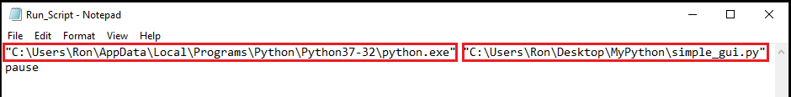

Now save the Notepad with a ‘bat’ extension. Here, I named the batch file as **Run_Script.bat**:

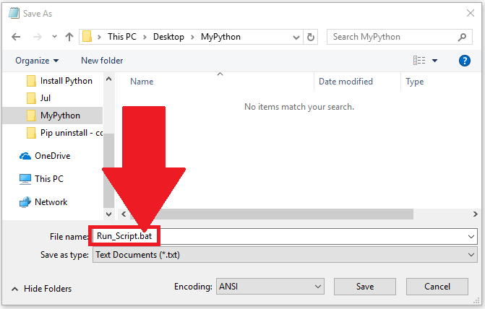

### **Step 4: Run the Batch File**

Your batch file is now ready to go. Double-click on that batch file:

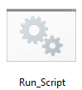

Your Python script will run now…

For our example, the [Python GUI](https://datatofish.com/how-to-create-a-gui-in-python/) will be displayed as follows:



That’s it, mission accomplished!